# **IST769 Homework Submission**

Name: **Sathish Kumar Rajendiran**   
SUID: **666555028**  
Email: srajendi@syr.edu  
Date Due: **07/27/2021**

Date Due: **Transactions and Temporal Tables**

Homework #:**3**

**Exercise(s):**

1. **In the Demo database, create two tables:**
   1. **The first table players should have columns player id (int pk), player name (varchar), shots attempted (int) shots made (int)**
   2. **The second table shots should have columns shot id (int pk), player id (int fk to players), clock time (datetime) shot made (bit)**
   3. **Add two players to the players table. Mary and Sue initialize the players with 0 shots attempted and made.**

**Solution:**

*************************************************************************************************

Drop players and shots user tables if exist

***********************************************************************************************/

/*********** Cleaning up History Table *******************/

---Turn Versioning Off

ALTER TABLE dbo.players

SET (SYSTEM_VERSIONING = OFF);

GO

IF EXISTS (SELECT * FROM INFORMATION_SCHEMA.TABLES WHERE TABLE_NAME='shots')

BEGIN

DROP TABLE dbo.shots

END

GO

IF EXISTS (SELECT * FROM INFORMATION_SCHEMA.TABLES WHERE TABLE_NAME='players')

BEGIN

DROP TABLE dbo.players

END

GO

IF EXISTS (SELECT * FROM INFORMATION_SCHEMA.TABLES WHERE TABLE_NAME='players_history')

BEGIN

DROP TABLE dbo.players_history

END

GO

IF EXISTS (SELECT * FROM INFORMATION_SCHEMA.TABLES WHERE TABLE_NAME='DB_Errors')

BEGIN

DROP TABLE dbo.DB_Errors

END

GO

/*********************** Table Creation **************/

----dbo.players table creation

CREATE TABLE dbo.players(

player_id INT NOT NULL IDENTITY,

player_name VARCHAR(80) NOT NULL,

shots_attempted INT,

shots_made INT,

CONSTRAINT players_PK PRIMARY KEY (player_id)

)

GO

----dbo.shots table creation

CREATE TABLE dbo.shots(

shot_id INT NOT NULL IDENTITY PRIMARY KEY,

player_id INT NOT NULL FOREIGN KEY REFERENCES dbo.players(player_id),

clock_time DATETIME NOT NULL,

shot_made BIT NOT NULL default 'FALSE'

)

GO

---- Table to record errors

CREATE TABLE dbo.DB_Errors

(ErrorID INT IDENTITY(1, 1),

UserName VARCHAR(100),

ErrorNumber INT,

ErrorState INT,

ErrorSeverity INT,

ErrorLine INT,

ErrorProcedure VARCHAR(MAX),

ErrorMessage VARCHAR(MAX),

ErrorDateTime DATETIME)

GO

/*********************** Data Population **************************/

INSERT INTO players (player_name, shots_attempted, shots_made)

VALUES ('Mary', 0, 0),('Sue',0,0)

GO

SELECT * from dbo.players

GO

SELECT * from dbo.shots

GO

**Evidence:**

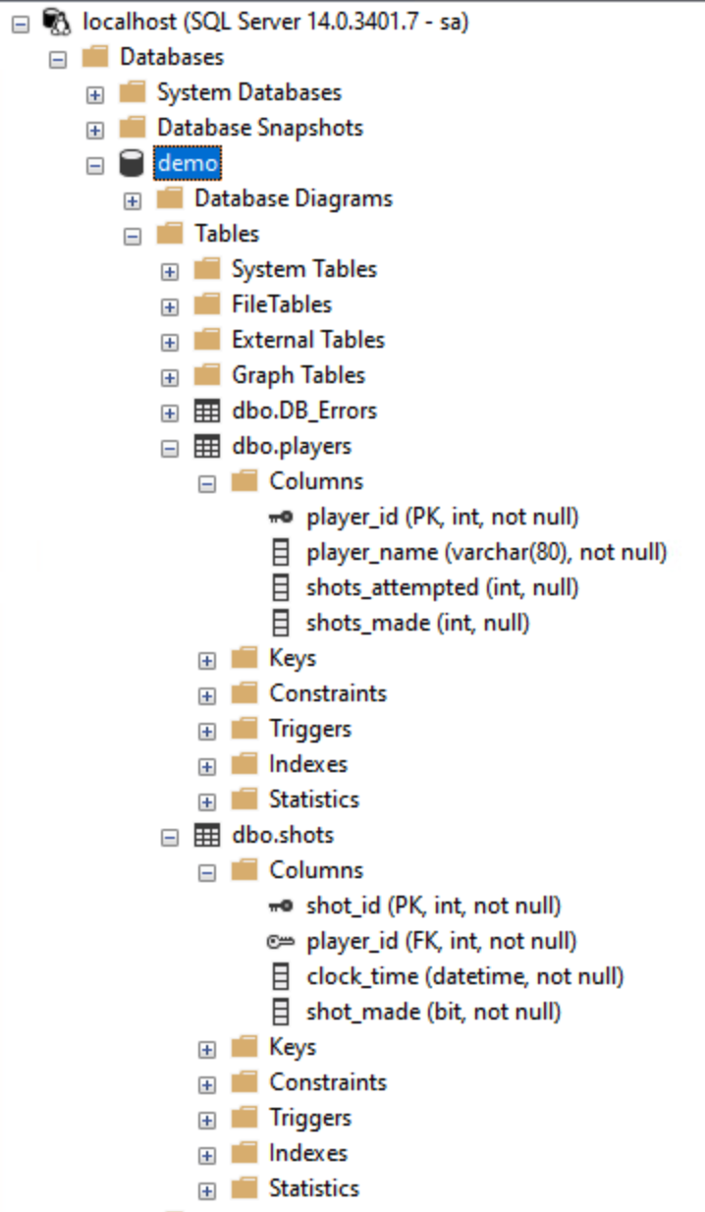

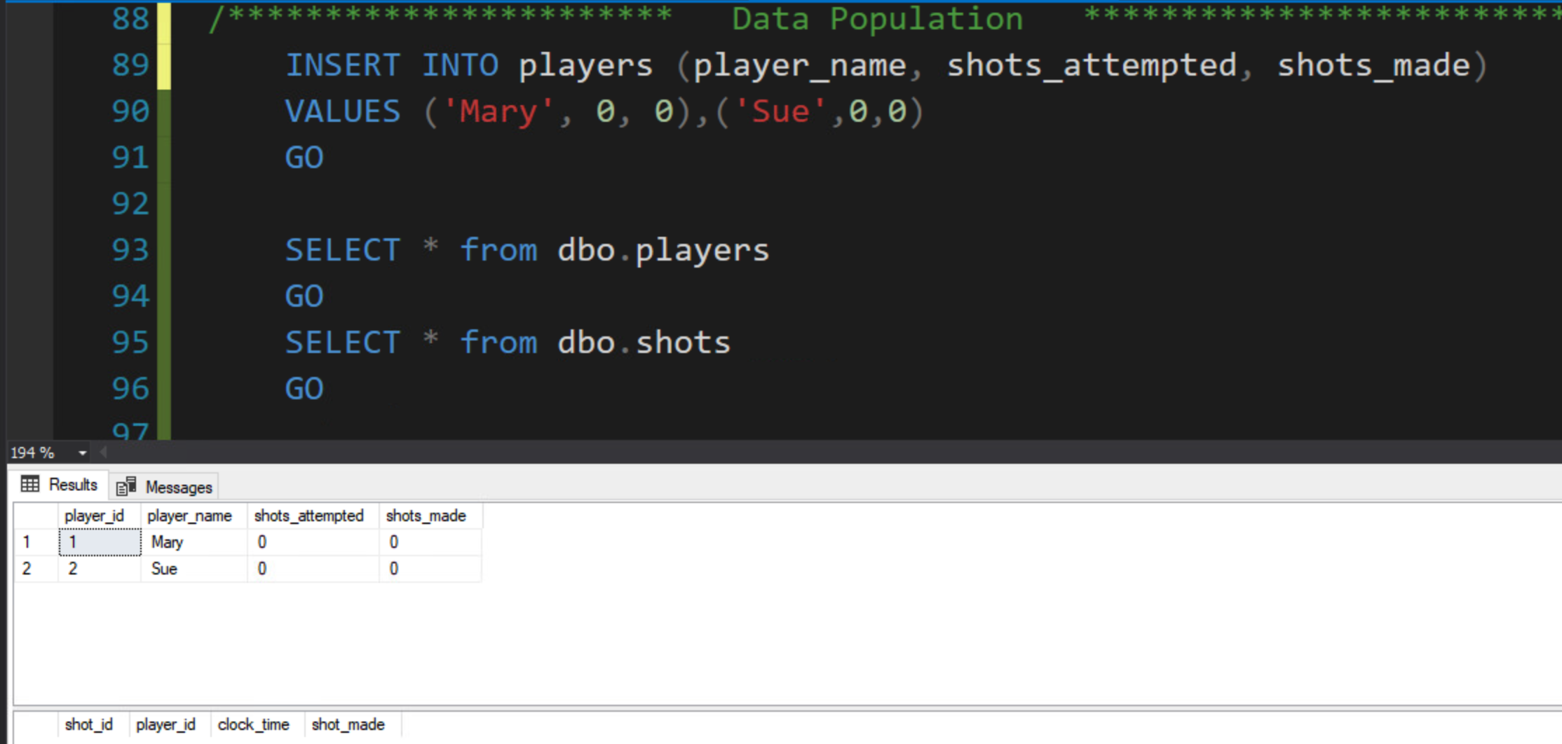

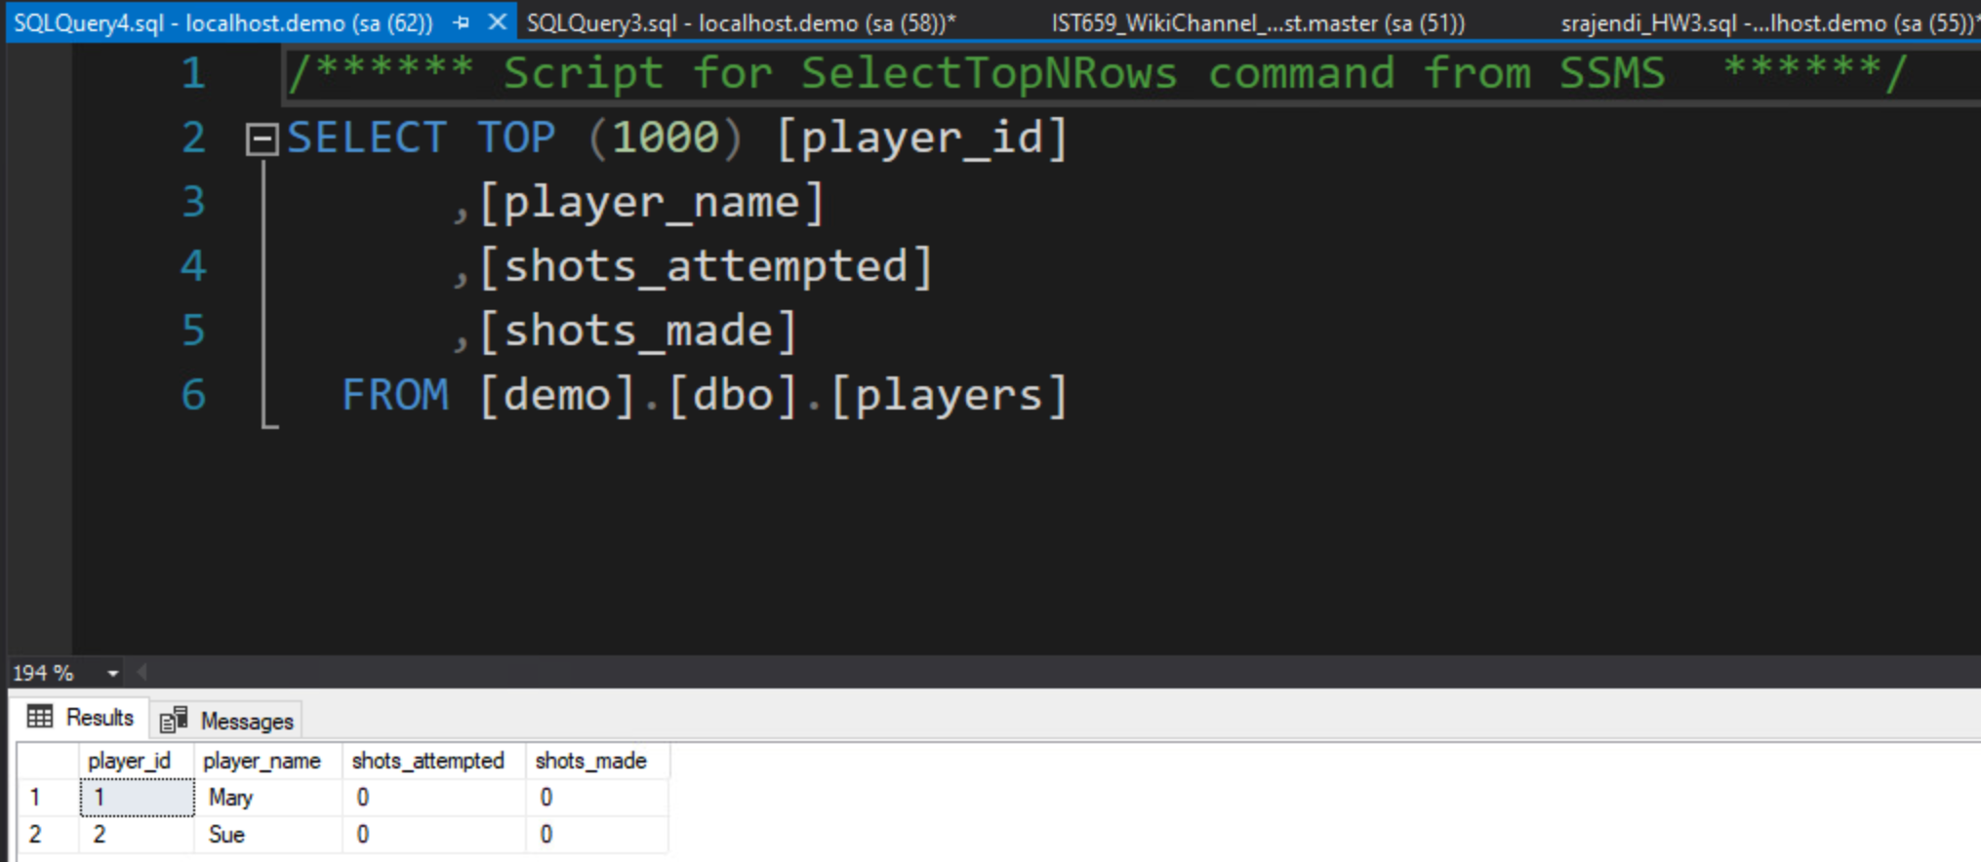

1. **Write transaction safe code as a stored procedure which when given a player id, clock time, and whether the shot was made (bit value) will add the record to the shots table and update the player record in the players table. For example, If Mary takes a shot and makes it, then misses the next one, there would be two records in the shots table and her row in the players table should have 2 attempt and 1 shot made. Execute the stored procedure to demonstrate the transaction is ACID compliant.**

**Solution:**

IF EXISTS (SELECT * FROM INFORMATION_SCHEMA.ROUTINES WHERE ROUTINE_NAME='p_write_shot')

BEGIN

DROP PROCEDURE p_write_shot

END

GO

CREATE PROCEDURE dbo.p_write_shot(

@player_id INT,

@clock_time datetime,

@shot_made bit

)

AS

BEGIN TRY

BEGIN TRANSACTION

INSERT INTO dbo.shots (player_id, clock_time, shot_made)

SELECT @player_id, @clock_time,@shot_made

---- if @@ROWCOUNT <> 1

----THROW 50005, 'Failed to insert into shots table, zero rows affected',0;

UPDATE dbo.players

SET shots_attempted = COALESCE (shots_attempted, 0) + 1,

shots_made = CASE @shot_made WHEN 1 THEN COALESCE (shots_made, 0) + 1

ELSE shots_made END

WHERE player_id = @player_id

---- if @@ROWCOUNT <> 1

----THROW 50006,'Failed to update into player table, zero rows affected',0;

COMMIT TRANSACTION

END TRY

BEGIN CATCH

INSERT INTO dbo.DB_Errors

VALUES

(SUSER_SNAME(),

ERROR_NUMBER(),

ERROR_STATE(),

ERROR_SEVERITY(),

ERROR_LINE(),

ERROR_PROCEDURE(),

ERROR_MESSAGE(),

GETDATE());

---- Transaction uncommittable

IF (XACT_STATE()) = -1

ROLLBACK TRANSACTION

---- Transaction committable

IF (XACT_STATE()) = 1

COMMIT TRANSACTION

END CATCH

GO

/********* Validation **********************************************************************/

--select * from dbo.players

--select * from dbo.shots

EXEC dbo.p_write_shot @player_id=1, @clock_time='2021/07/26 16:00:00', @shot_made='TRUE'

GO

EXEC dbo.p_write_shot @player_id=1, @clock_time='2021/07/26 16:05:00', @shot_made='TRUE'

GO

EXEC dbo.p_write_shot @player_id=2, @clock_time='2021/07/26 16:00:00', @shot_made='TRUE'

GO

EXEC dbo.p_write_shot @player_id=2, @clock_time='2021/07/26 16:05:00', @shot_made='FALSE'

GO

EXEC dbo.p_write_shot @player_id=1, @clock_time='2021/07/26 16:00:00', @shot_made='TRUE'

GO

EXEC dbo.p_write_shot @player_id=1, @clock_time='2021/07/26 16:05:00', @shot_made='TRUE'

GO

----negative scenarios

EXEC dbo.p_write_shot @player_id=10, @clock_time='2021/07/26 16:00:00', @shot_made='TRUE' --foreign key violation on player_id - failure

GO

EXEC dbo.p_write_shot @player_id=1, @clock_time='2021/07/26 16:00:00',@shot_made=NULL --NOT NULL exception -failure

GO

select * from dbo.shots

select * from dbo.players

select * from dbo.DB_Errors

**Evidence:**

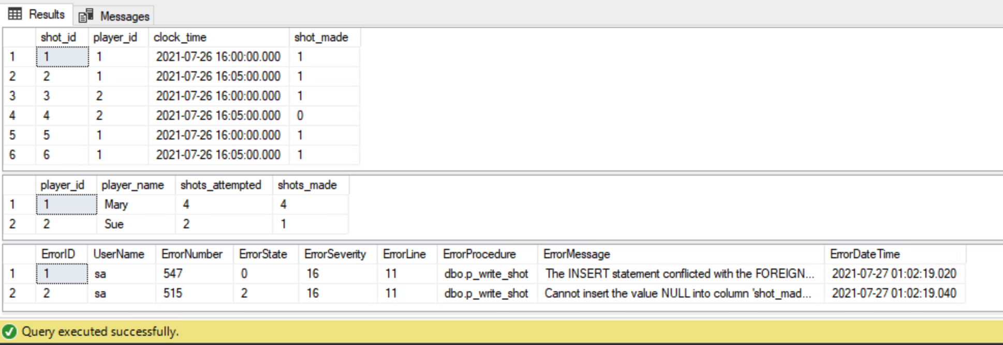

1. Alter the **players** table to be a system-versioned temporal table.

**Solution:**

----alter dbo.players table to add hidden columns that are used as version columns

ALTER TABLE dbo.players

----Add the system versioning history table

ADD StartTime DATETIME2 GENERATED ALWAYS AS ROW START

HIDDEN DEFAULT GETUTCDATE(),

EndTime DATETIME2 GENERATED ALWAYS AS ROW END

HIDDEN DEFAULT

CONVERT(DATETIME2, '9999-12-31 23:59:59.9999999'),

PERIOD FOR SYSTEM_TIME (StartTime, EndTime);

GO

----Turn on the System_Versioning to player table on players_history table

ALTER TABLE dbo.players

SET (SYSTEM_VERSIONING = ON (HISTORY_TABLE=dbo.players_history));

GO

**Evidence:**

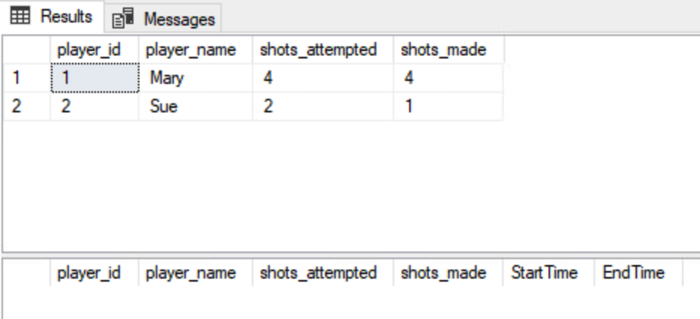

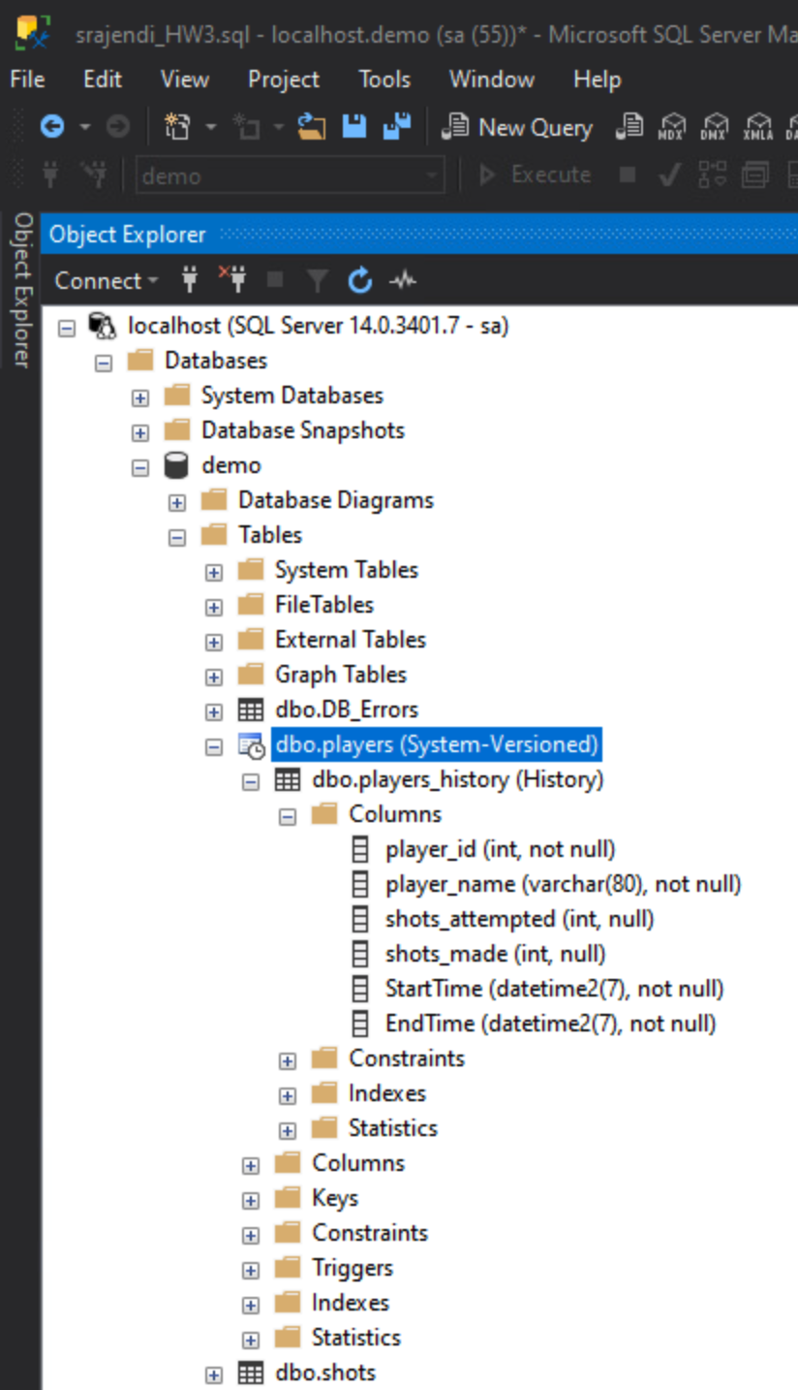

1. **Execute your stored procedure from part 2 to create at least 15 shot records over a 5-minute period. Make sure there are records in the first ½ of the 5-minute period and at few in the last minute of the 5-minute period.**

**Solution:**

/* Delete all records from shots and players table */

--Delete from dbo.shots

--Go

--Delete from dbo.players

--Go

SELECT * FROM dbo.players

SELECT * FROM dbo.shots

--***********************insert records*******************************************

--INSERT INTO players (player_name, shots_attempted, shots_made)

--VALUES ('Mary', 0, 0),('Sue',0,0)

--GO

EXEC dbo.p_write_shot @player_id=1, @clock_time = '2021/07/26 18:55:00',@shot_made =1;

WAITFOR DELAY '00:00:05'

EXEC dbo.p_write_shot @player_id=2, @clock_time = '2021/07/26 18:55:10',@shot_made =1

WAITFOR DELAY '00:00:05'

EXEC dbo.p_write_shot @player_id=1, @clock_time = '2021/07/26 18:55:20',@shot_made =1;

WAITFOR DELAY '00:00:05'

EXEC dbo.p_write_shot @player_id=2, @clock_time = '2021/07/26 18:55:30',@shot_made =1

WAITFOR DELAY '00:00:05'

EXEC dbo.p_write_shot @player_id=1, @clock_time = '2021/07/26 18:55:40',@shot_made =1;

WAITFOR DELAY '00:00:05'

EXEC dbo.p_write_shot @player_id=2, @clock_time = '2021/07/26 18:55:50',@shot_made =1;

WAITFOR DELAY '00:00:05'

EXEC dbo.p_write_shot @player_id=1, @clock_time = '2021/07/26 18:56:00',@shot_made =1;

WAITFOR DELAY '00:00:05'

EXEC dbo.p_write_shot @player_id=2, @clock_time = '2021/07/26 18:56:10',@shot_made =1;

WAITFOR DELAY '00:00:05'

EXEC dbo.p_write_shot @player_id=1, @clock_time = '2021/07/26 18:56:20',@shot_made =0;

WAITFOR DELAY '00:00:05'

EXEC dbo.p_write_shot @player_id=2, @clock_time = '2021/07/26 18:56:30',@shot_made =1;

WAITFOR DELAY '00:00:05'

EXEC dbo.p_write_shot @player_id=1, @clock_time = '2021/07/26 18:56:40',@shot_made =1;

WAITFOR DELAY '00:00:05'

EXEC dbo.p_write_shot @player_id=2, @clock_time = '2021/07/26 18:56:50',@shot_made =0

WAITFOR DELAY '00:00:05'

EXEC dbo.p_write_shot @player_id=1, @clock_time = '2021/07/26 18:57:00',@shot_made =1;

WAITFOR DELAY '00:00:05'

EXEC dbo.p_write_shot @player_id=2, @clock_time = '2021/07/26 18:57:10',@shot_made =0;

WAITFOR DELAY '00:00:05'

EXEC dbo.p_write_shot @player_id=1, @clock_time = '2021/07/26 18:57:20',@shot_made =0;

WAITFOR DELAY '00:00:05'

EXEC dbo.p_write_shot @player_id=2, @clock_time = '2021/07/26 18:57:30',@shot_made =0;

WAITFOR DELAY '00:00:05'

EXEC dbo.p_write_shot @player_id=1, @clock_time = '2021/07/26 18:57:40',@shot_made =0;

WAITFOR DELAY '00:00:05'

EXEC dbo.p_write_shot @player_id=2, @clock_time = '2021/07/26 18:57:50',@shot_made =1;

WAITFOR DELAY '00:00:05'

EXEC dbo.p_write_shot @player_id=1, @clock_time = '2021/07/26 18:58:00',@shot_made =1;

WAITFOR DELAY '00:00:05'

EXEC dbo.p_write_shot @player_id=2, @clock_time = '2021/07/26 18:58:10',@shot_made =0;

WAITFOR DELAY '00:00:05'

EXEC dbo.p_write_shot @player_id=1, @clock_time = '2021/07/26 18:58:20',@shot_made =1;

WAITFOR DELAY '00:00:05'

EXEC dbo.p_write_shot @player_id=2, @clock_time = '2021/07/26 18:58:30',@shot_made =1;

WAITFOR DELAY '00:00:05'

EXEC dbo.p_write_shot @player_id=1, @clock_time = '2021/07/26 18:58:40',@shot_made =1;

WAITFOR DELAY '00:00:05'

EXEC dbo.p_write_shot @player_id=2, @clock_time = '2021/07/26 18:58:50',@shot_made =1;

WAITFOR DELAY '00:00:05'

EXEC dbo.p_write_shot @player_id=1, @clock_time = '2021/07/26 18:59:00',@shot_made =1;

WAITFOR DELAY '00:00:05'

EXEC dbo.p_write_shot @player_id=2, @clock_time = '2021/07/26 18:59:10',@shot_made =1;

WAITFOR DELAY '00:00:05'

EXEC dbo.p_write_shot @player_id=1, @clock_time = '2021/07/26 18:59:20',@shot_made =1;

WAITFOR DELAY '00:00:05'

EXEC dbo.p_write_shot @player_id=2, @clock_time = '2021/07/26 18:59:30',@shot_made =1;

WAITFOR DELAY '00:00:05'

EXEC dbo.p_write_shot @player_id=1, @clock_time = '2021/07/26 18:59:40',@shot_made =1;

WAITFOR DELAY '00:00:05'

EXEC dbo.p_write_shot @player_id=2, @clock_time = '2021/07/26 18:59:50',@shot_made =1;

WAITFOR DELAY '00:00:05'

EXEC dbo.p_write_shot @player_id=1, @clock_time = '2021/07/26 19:00:00',@shot_made =1;

WAITFOR DELAY '00:00:05'

EXEC dbo.p_write_shot @player_id=2, @clock_time = '2021/07/26 19:00:10',@shot_made =1;

WAITFOR DELAY '00:00:05'

EXEC dbo.p_write_shot @player_id=1, @clock_time = '2021/07/26 19:00:20',@shot_made =1;

WAITFOR DELAY '00:00:05'

EXEC dbo.p_write_shot @player_id=2, @clock_time = '2021/07/26 19:00:30',@shot_made =1

WAITFOR DELAY '00:00:05'

EXEC dbo.p_write_shot @player_id=1, @clock_time = '2021/07/26 19:00:40',@shot_made =1;

WAITFOR DELAY '00:00:05'

EXEC dbo.p_write_shot @player_id=2, @clock_time = '2021/07/26 19:00:50',@shot_made =1

WAITFOR DELAY '00:00:05'

EXEC dbo.p_write_shot @player_id=1, @clock_time = '2021/07/26 19:01:00',@shot_made =1;

WAITFOR DELAY '00:00:05'

EXEC dbo.p_write_shot @player_id=2, @clock_time = '2021/07/26 19:01:10',@shot_made =1;

WAITFOR DELAY '00:00:05'

EXEC dbo.p_write_shot @player_id=1, @clock_time = '2021/07/26 19:01:20',@shot_made =1;

WAITFOR DELAY '00:00:05'

EXEC dbo.p_write_shot @player_id=2, @clock_time = '2021/07/26 19:01:30',@shot_made =1;

WAITFOR DELAY '00:00:05'

EXEC dbo.p_write_shot @player_id=1, @clock_time = '2021/07/26 19:01:40',@shot_made =0;

WAITFOR DELAY '00:00:05'

EXEC dbo.p_write_shot @player_id=2, @clock_time = '2021/07/26 19:01:50',@shot_made =1;

WAITFOR DELAY '00:00:05'

EXEC dbo.p_write_shot @player_id=1, @clock_time = '2021/07/26 19:02:00',@shot_made =1;

WAITFOR DELAY '00:00:05'

EXEC dbo.p_write_shot @player_id=2, @clock_time = '2021/07/26 19:02:10',@shot_made =0

WAITFOR DELAY '00:00:05'

EXEC dbo.p_write_shot @player_id=1, @clock_time = '2021/07/26 19:02:20',@shot_made =1;

WAITFOR DELAY '00:00:05'

EXEC dbo.p_write_shot @player_id=2, @clock_time = '2021/07/26 19:02:30',@shot_made =0;

WAITFOR DELAY '00:00:05'

EXEC dbo.p_write_shot @player_id=1, @clock_time = '2021/07/26 19:02:40',@shot_made =0;

WAITFOR DELAY '00:00:05'

EXEC dbo.p_write_shot @player_id=2, @clock_time = '2021/07/26 19:02:50',@shot_made =0;

WAITFOR DELAY '00:00:05'

EXEC dbo.p_write_shot @player_id=1, @clock_time = '2021/07/26 19:03:00',@shot_made =0;

WAITFOR DELAY '00:00:05'

EXEC dbo.p_write_shot @player_id=2, @clock_time = '2021/07/26 19:03:10',@shot_made =1;

WAITFOR DELAY '00:00:05'

EXEC dbo.p_write_shot @player_id=1, @clock_time = '2021/07/26 19:03:20',@shot_made =1;

WAITFOR DELAY '00:00:05'

EXEC dbo.p_write_shot @player_id=2, @clock_time = '2021/07/26 19:03:30',@shot_made =0;

WAITFOR DELAY '00:00:05'

EXEC dbo.p_write_shot @player_id=1, @clock_time = '2021/07/26 19:03:40',@shot_made =1;

WAITFOR DELAY '00:00:05'

EXEC dbo.p_write_shot @player_id=2, @clock_time = '2021/07/26 19:03:50',@shot_made =1;

WAITFOR DELAY '00:00:05'

EXEC dbo.p_write_shot @player_id=1, @clock_time = '2021/07/26 19:04:00',@shot_made =1;

WAITFOR DELAY '00:00:05'

EXEC dbo.p_write_shot @player_id=2, @clock_time = '2021/07/26 19:04:10',@shot_made =1;

WAITFOR DELAY '00:00:05'

EXEC dbo.p_write_shot @player_id=1, @clock_time = '2021/07/26 19:04:20',@shot_made =1;

WAITFOR DELAY '00:00:05'

EXEC dbo.p_write_shot @player_id=2, @clock_time = '2021/07/26 19:04:30',@shot_made =1;

WAITFOR DELAY '00:00:05'

EXEC dbo.p_write_shot @player_id=1, @clock_time = '2021/07/26 19:04:40',@shot_made =1;

WAITFOR DELAY '00:00:05'

EXEC dbo.p_write_shot @player_id=2, @clock_time = '2021/07/26 19:04:50',@shot_made =1;

WAITFOR DELAY '00:00:05'

EXEC dbo.p_write_shot @player_id=1, @clock_time = '2021/07/26 19:05:00',@shot_made =1;

WAITFOR DELAY '00:00:05'

EXEC dbo.p_write_shot @player_id=2, @clock_time = '2021/07/26 19:05:10',@shot_made =1;

WAITFOR DELAY '00:00:05'

EXEC dbo.p_write_shot @player_id=1, @clock_time = '2021/07/26 19:05:20',@shot_made =1;

WAITFOR DELAY '00:00:05'

EXEC dbo.p_write_shot @player_id=2, @clock_time = '2021/07/26 19:05:30',@shot_made =1;

WAITFOR DELAY '00:00:05'

SELECT * FROM dbo.players

select * from dbo.players_history

**Evidence:**

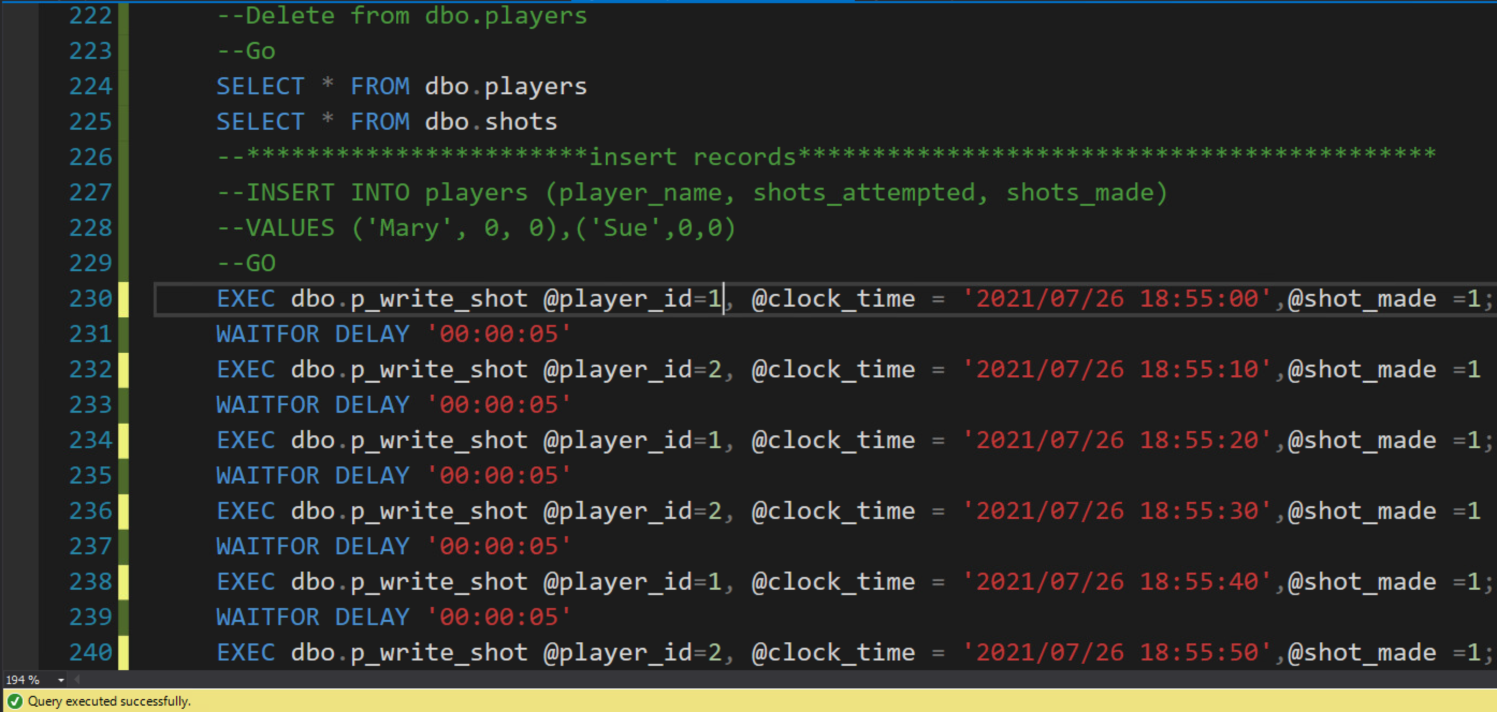

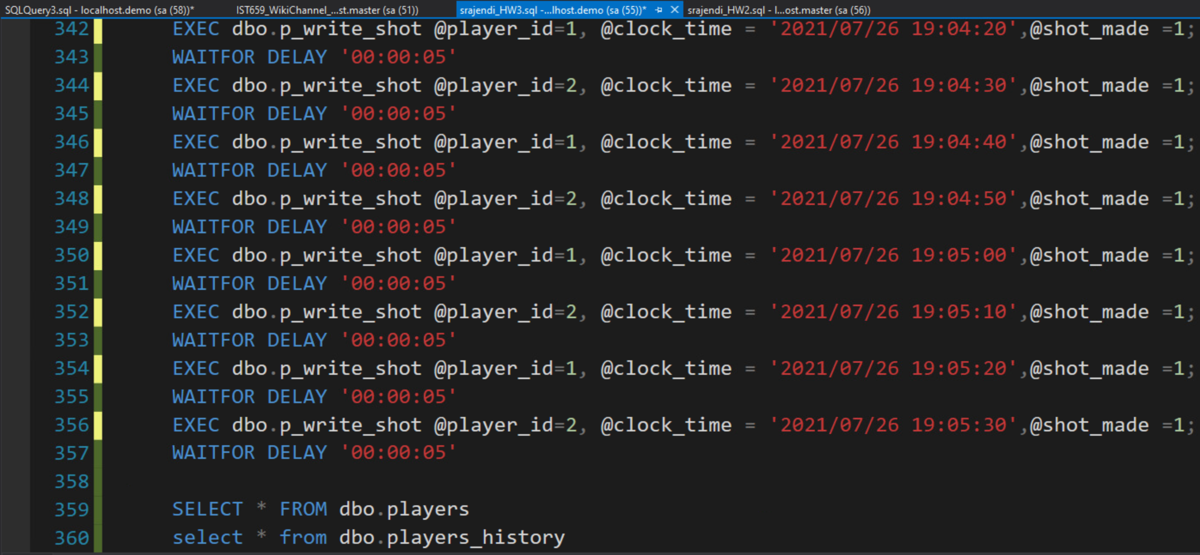

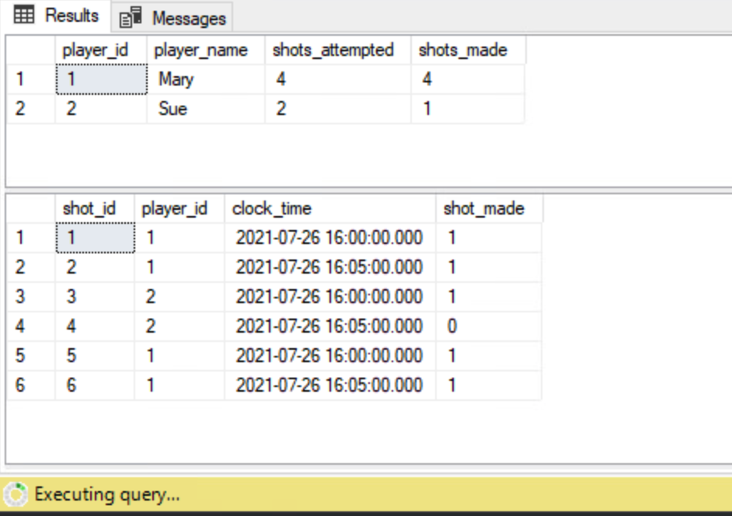

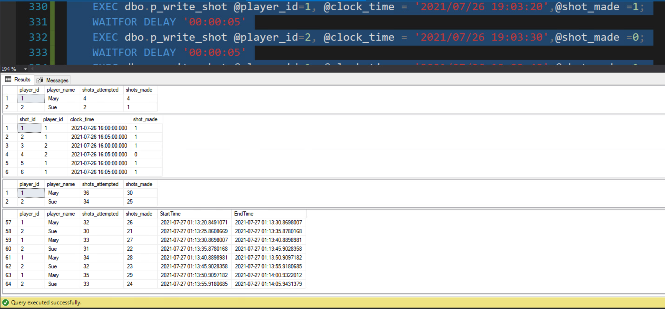

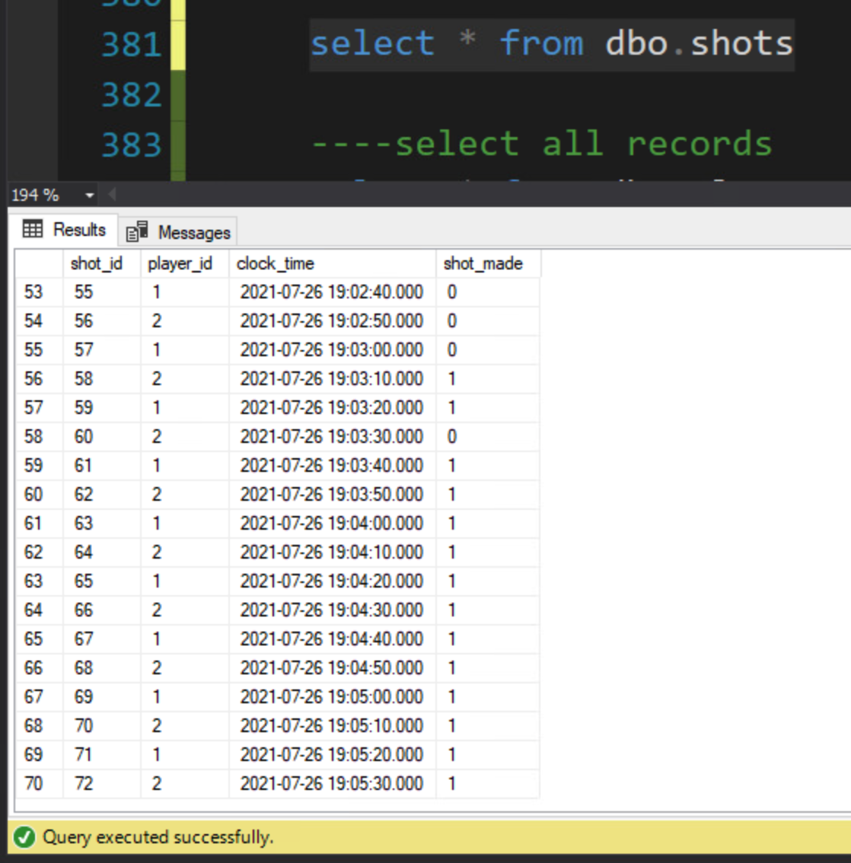

1. **Write SQL queries to show:**
   1. **The player statistics at the end of the 5-minute period (current statistics).**
   2. **The player statistics exactly 2 minutes and 30 seconds into the period.**
   3. **The player statistics in the last minute of the period.**

**Solution:**

--time range

select

min(StartTime) min_StartTime

,min(EndTime) min_EndTime

,max(StartTime) max_StartTime

,max(EndTime) max_EndTime

,datediff(minute,min(StartTime),max(StartTime)) startTime_range_in_minutes

,datediff(minute,min(EndTime),max(EndTime)) endtime_range_in_minutes

,datediff(minute,min(StartTime),max(EndTime)) overall_range_in_minutes

from dbo.players_history

--where player_id in(5,6)

----select with as of time frame record

select * from dbo.players

for system_time AS OF '2021-07-27 01:14'

----select changes between time frames

select * from dbo.players

for system_time between '2021-07-27 01:04:00' and '2021-07-27 01:06:30'

----select changes in the last minute

select * from dbo.players

for system_time between '2021-07-27 01:14:00' and '2021-07-27 01:14:00'

**Evidence:**

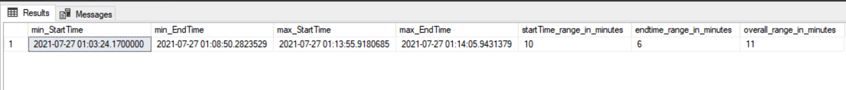

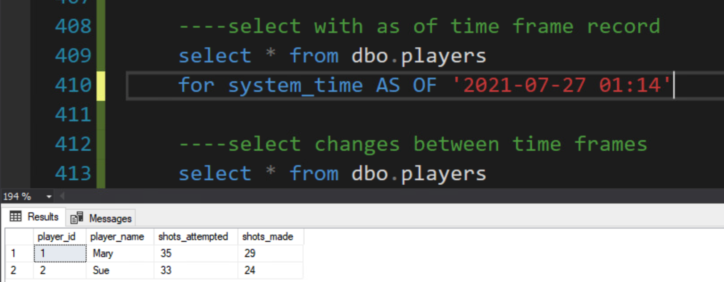

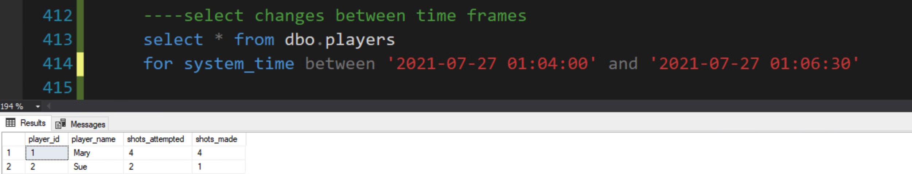

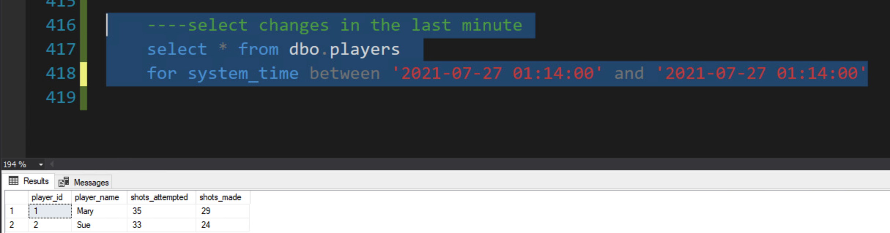

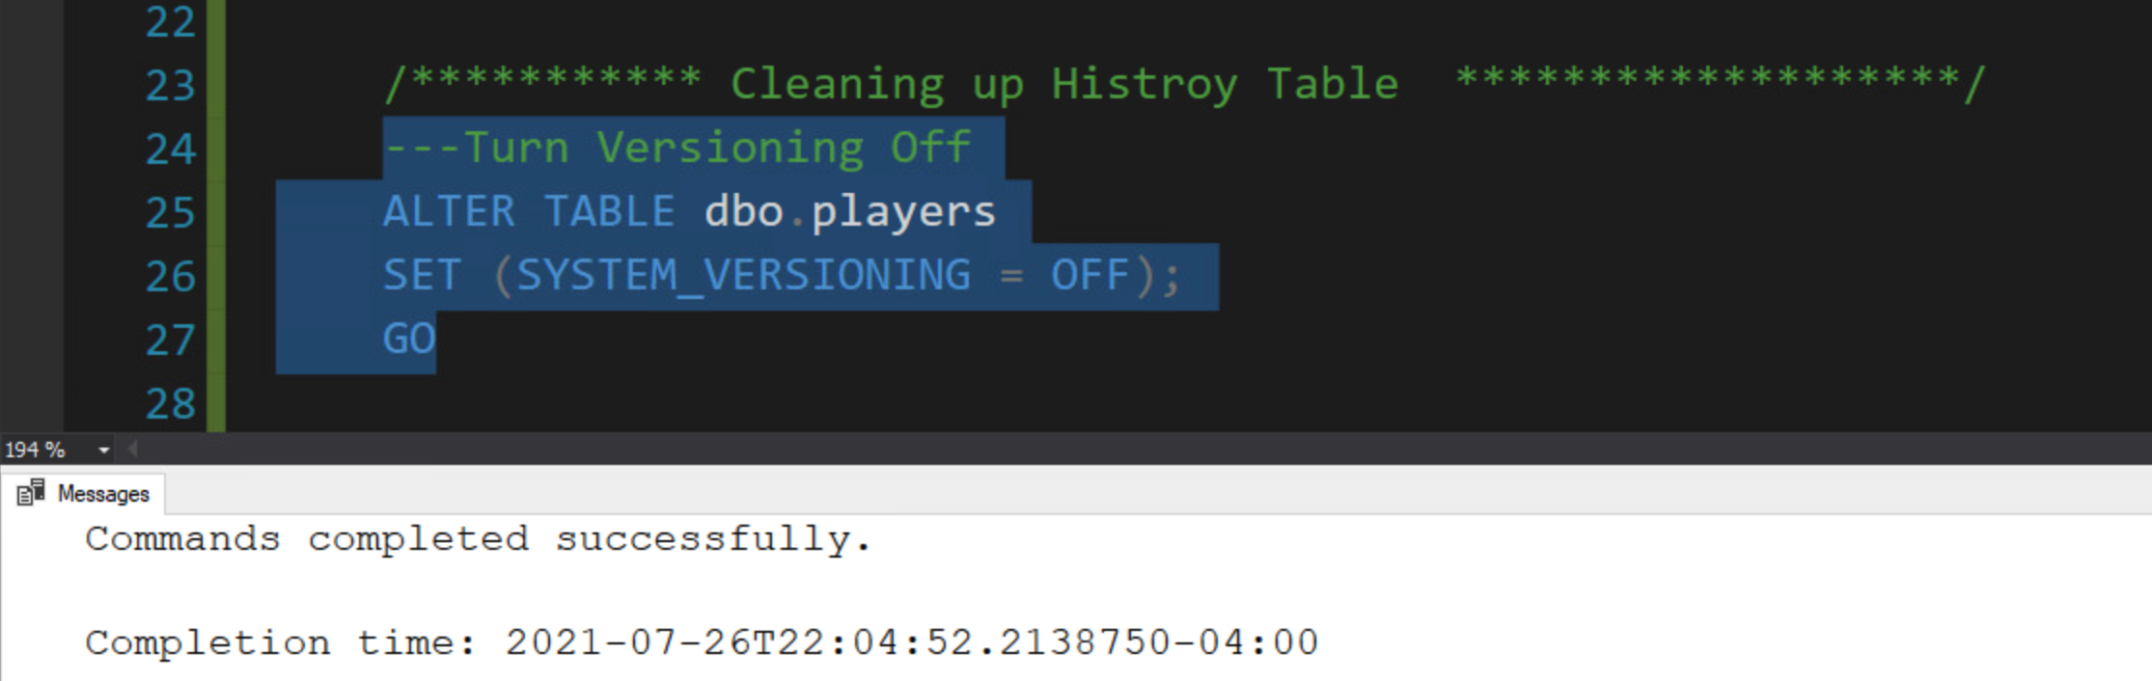

# **Appendix**

